14.89: a) The tension in the cord plus the weight must be equal to the buoyant force, so

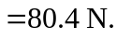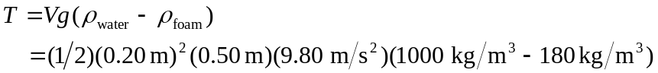

b) The depth of the bottom of the styrofoam is not given; let this depth be 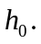 Denote the length of the piece of foam by L and the length of the two sides by l. The pressure force on the bottom of the foam is then 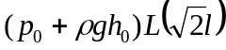 and is directed up. The pressure on each side is not constant; the force can be found by integrating, or using the result of Problem 14.44 or Problem 14.46. Although these problems found forces on vertical surfaces, the result that the force is the product of the average pressure and the area is valid. The average pressure is 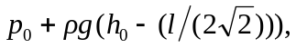 and the force on one side has magnitude
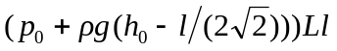

and is directed perpendicular to the side, at an angle of 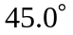 from the vertical. The force on the other side has the same magnitude, but has a horizontal component that is opposite that of the other side. The horizontal component of the net buoyant force is zero, and the vertical component is

the weight of the water displaced.

